Warranty & Service Contract Awards
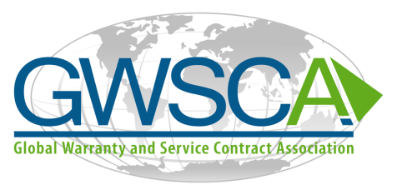

Submission Guidelines/Criteria
Awards will be presented in the following categories:
- Excellence in Warranty
- Excellence in Service Contract
- Innovation in Warranty
- Innovation in Service Contract
Awards will be presented at the 2016 GWSCA Conference on Warranty and Service Contracts this September in Chicago. Award recipients will receive industry recognition in WarrantyWeek® magazine.

Nominations
Submissions must be postmarked or emailed & confirmed received by
August 1, 2016

Deadline
You may nominate your company or other companies for consideration. Information submitted with remain proprietary for use only by the awards evaluation committee and not returned. Details on next page.
You may nominate your company or another company for consideration. Information submitted will remain proprietary for use only by the awards evaluation committee and will not be returned.

Award Categories & Presentation
Developing and sustaining exceptional warranty and/or service contract capabilities has become increasingly critical as the need to improve quality, and retain customers and competitive advantage grows in the recovering economy. Companies who harness these capabilities can achieve greater revenues at higher profitability, and healthier customer loyalty.
The Global Warranty and Service Contract Association will recognize an exceptional few brand owners or companies that offer product warranties, and/or service contracts that are nominated for a Warranty and Service Contract Award, and meet the required criteria.

Nominate Your Company or a Company You Know
Submit Nomination to:
Mail:
GWSCA
c/o Terry Hawkins, President
740 Zorn Ave, 5C
Louisville, KY 40206

Email: gterry.hawkins@gmail.com

NOMINATION DEADLINE
Friday, January 10, 2014

This form is also
available at
GWSCA.org./AboutUs NewsandEvents

2015-2016

Excellence in Warranty / Service Contracts
Looking for company's ability to achieve sustained excellence (year over year) and continuity of excellence in more than one of the following areas:
- Warranty Costs/Cost to Serve
- Warranty or Service Contract reserves accuracy
- Service Contracts Sales growth
- NPI related Warranty/Service Contract management
- Supplier Cost Recovery, Management and collaboration
- Customer Loyalty/Channel Management and collaborative customer and service practices
Nominations must include a detailed description of areas of performance, and provide actual numbers to back nomination, to show that the organization has achieved excellence in warranty/service., Provide examples/ exhibits of performance, financial and other relevant information (including description of time-frame processes or performance reflects and if practices/processes, performance are same or different today). Provide a description of how performance was/is achieved: e.g. Successful implementation of analytics, early warning, fraud detection, collaborative practices internally and with partners, etc.) Discuss organizational structure and support mechanisms to accomplish performance as well as what metrics were used internally and with partners to measure and achieve progress.

Companies can be nominated for up to two categories.

Previous GWSCA
Award Winners

Kohler Company 2015
Registria 2015
Warrantech 2015
PCMI 2015
Sheila Cardines 2015
Ashok Kartham 2015
Oracle 2014
Ford 2014
Seagate/Fulcrum 2014
Sub-Zero Wolf 2014
SCIC 2014
Eric Arnum – Warranty Week 2013
Alison Griffiths-ALG Associates 2013
Case New Holland 2012
Mitsubishi Caterpillar Forklift America 2012
Volvo Powertrain 2012

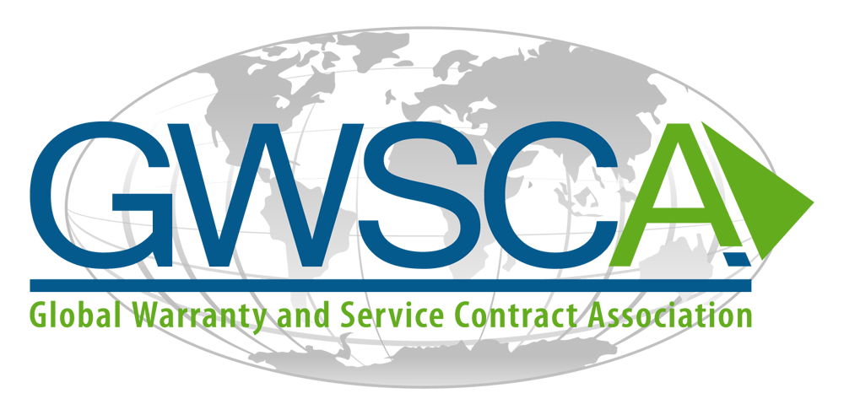

Innovation in Warranty / Service Contract
Looking for company's use of innovation in warranty and service contracts including utilizing new frameworks, approaches, technologies and the like, with the end result being a major improvement in warranty and or service contract, either internally with suppliers or customers. Example areas impacted may include:
- Warranty Costs/Cost to Serve
- Warranty/Service Contract reserves accuracy
- Service Contract Sales growth
- NPI related Warranty/Service Contract management
- Supplier Cost Recovery, Management and collaboration
- Customer Loyalty/Channel Management and collaborative customer and service practices
Nominations must include a detailed description of areas of performance, and provide actual numbers to back nomination, to show that the organization has achieved significant improvement related to warranty/service contracts, Provide examples/ exhibits of performance, financial and other relevant information (including description of time-frame processes or performance reflects). Provide a description of how performance was/is achieved and how innovation came about. Discuss organizational structure and support mechanisms to accomplish such performance as well as what metrics were used internally and with partners to measure and achieve progress.

.

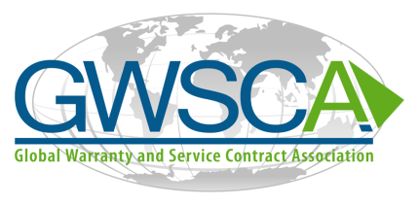
Become a member of the GWSCA Today!

DATE SUBMITTED:_______________________ RECEIVED BY GWSCA ______________________
NOMINEE INFORMATION
Company_____________________________________
Address_______________________________________
Phone________________________________________
Contact__________________________ , email address _________________________________
Nominated Catefory :
- Excellence in Warranty
- Excellence in Service Contract
- Innovation in Warranty
- Innovation in Service Contract

NOMINATED BY
Company_________________________________
Address___________________________________
Phone____________________________________
Contact__________________________________ , email address ___________________________

Describe why you are nominating this company
What are the quantitative measures
How was this achieved
Describe the organizational structure
PLEASE ATTACH ADDITIONAL EXHIBITS THAT SUPPORT THIS NOMINATION

